509428DKGRY
UPC: 021032549565

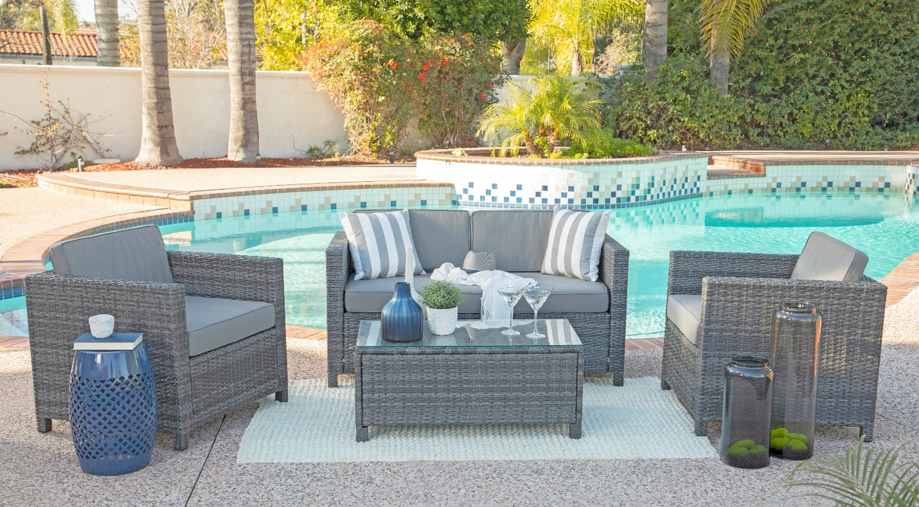
DESCRIPTION | Retail Price | TL Qty | Cost | CUFT | Width | Depth | Height
4 PC SET(2CHAIR+LOVESEAT+TABLE), DK GREY, 29.00 X 28.50 X 25.25"H | $999 | 150 Sets |  | 22.53 | 29.76 | 52.76 | 24.8

